|  |  |  |
| --- | --- | --- |
| Q1 | Which of the following properties of an AWS resource is sufficient and necessary to uniquely identify it across all of AWS? | |
|  | a) ARN |  |
|  | b) Region and ARN |  |
|  | c) ARN and Account number |  |
|  | d) Depends on the resource used |  |
|  | Enter your answer here | a |
|  |  |  |
| Q2 | Which of the following step numbers in Step 1 allowed S3 to publish to the SNS topic created? | |
|  | a) 1(a) |  |
|  | b) 1(c) |  |
| a | c) 1(d) |  |
|  | d) 1(b) |  |
|  | Enter your answer here | b |
| Q3 | Which port is being used by SNS to send the notification to the custom program? | |
|  | a) 8081 |  |
|  | b) 80 |  |
|  | c) 8080 |  |
|  | d) 8065 |  |
|  | Enter your answer here | c |
| Q4 | How many IAM roles can be attached to an EC2 instance at a time? | |

|  |  |  |  |
| --- | --- | --- | --- |
|  | a) 2 |  |  |
|  | b) 3 |  |  |
|  | c) 1 |  |  |
|  | d) Depends on the policies required |  |  |
|  | Enter your answer here | c |  |
| Q5 | As a product manager, how would you describe the benefits of this architecture to a client, as compared to an equivalent on-premises architecture? | | 5 |
| a | Points to be considered:   * Built-in triggers for event management connected to storage and computing * Built-in messaging service * Managed Database Service | |  |

# Step 1

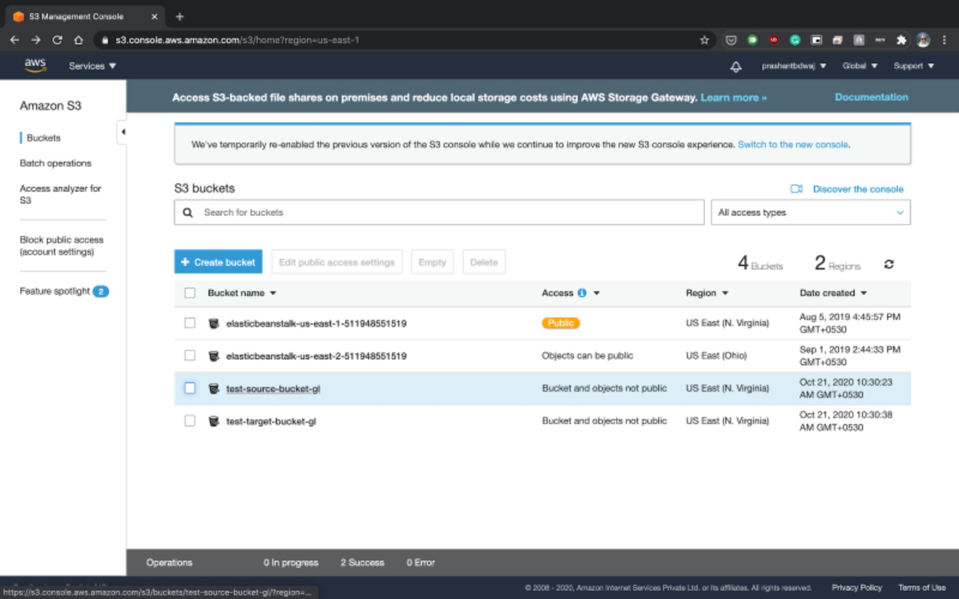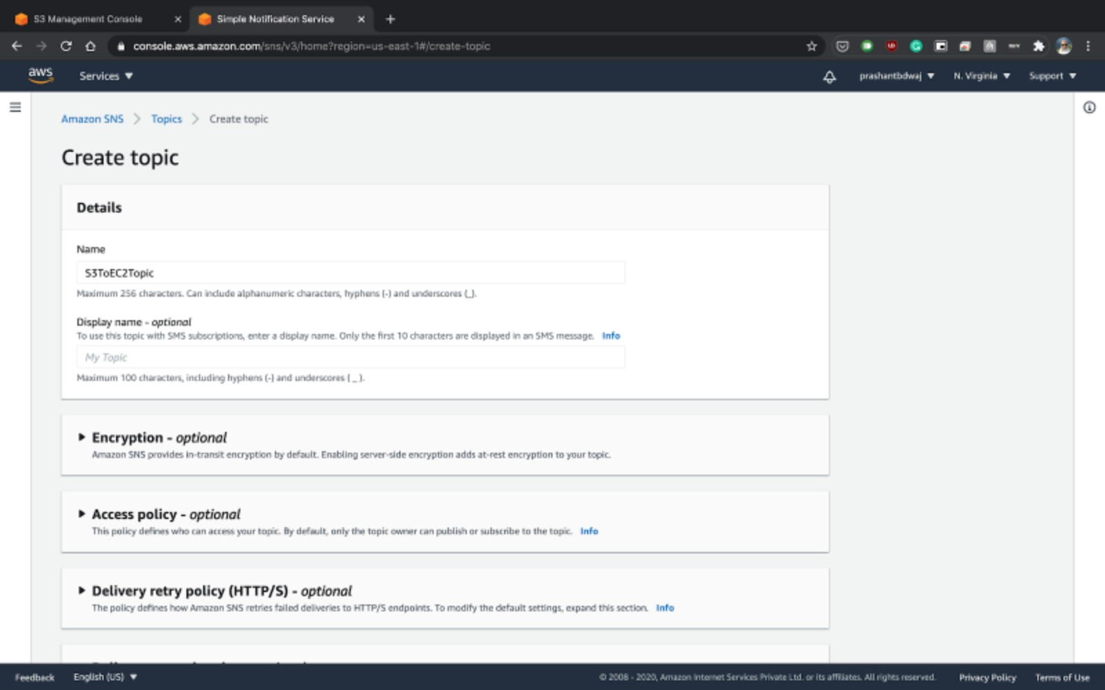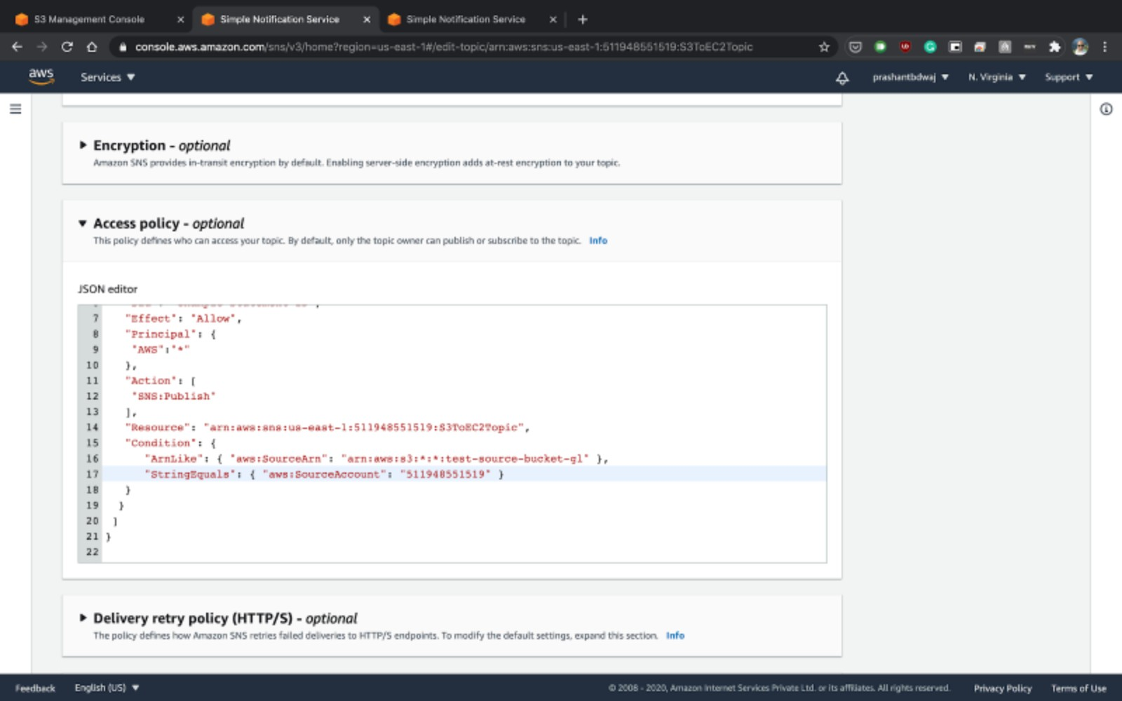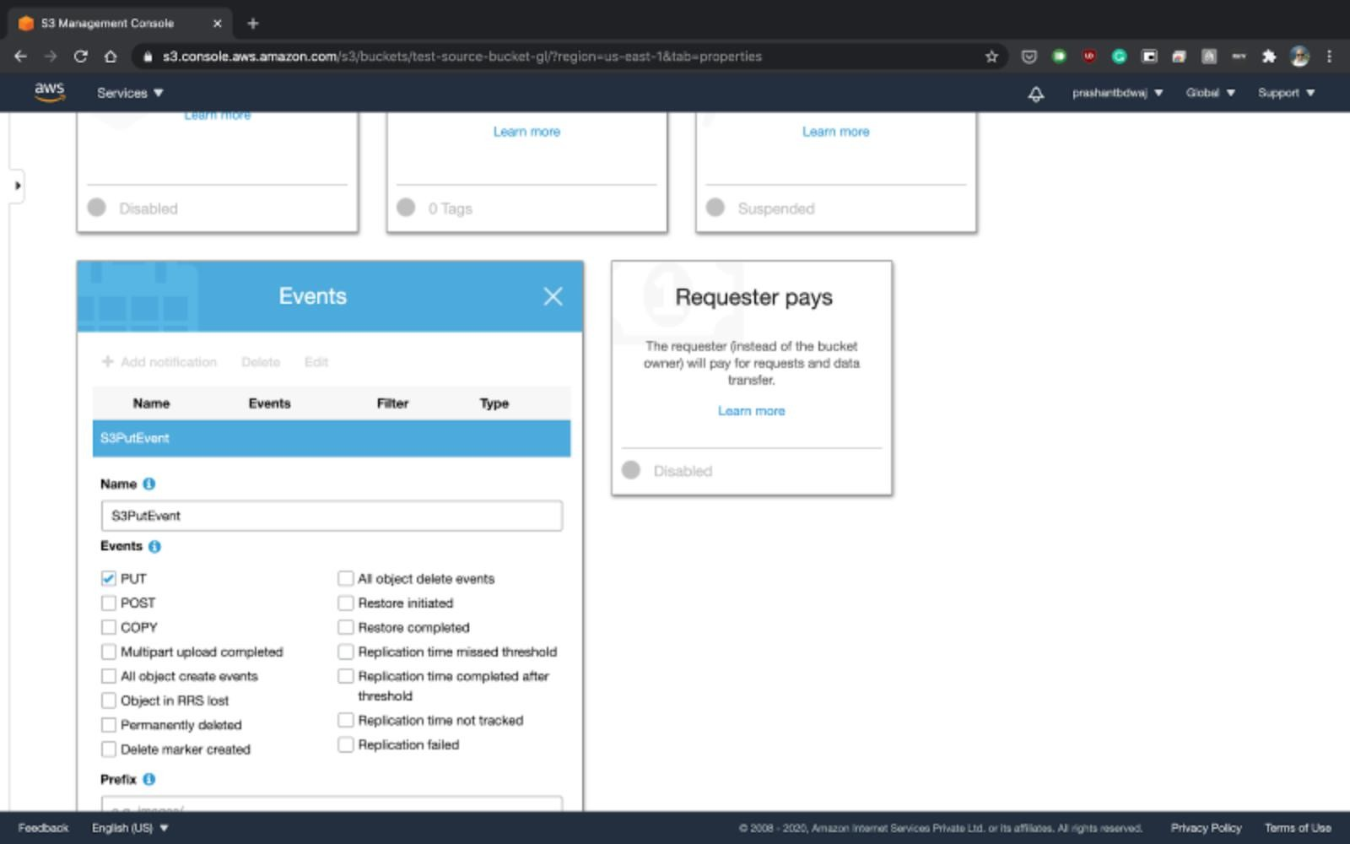

# Step 2

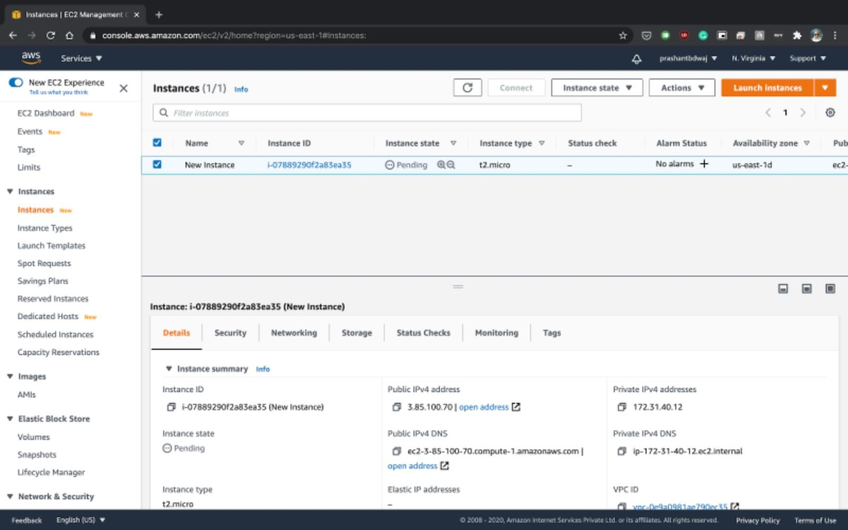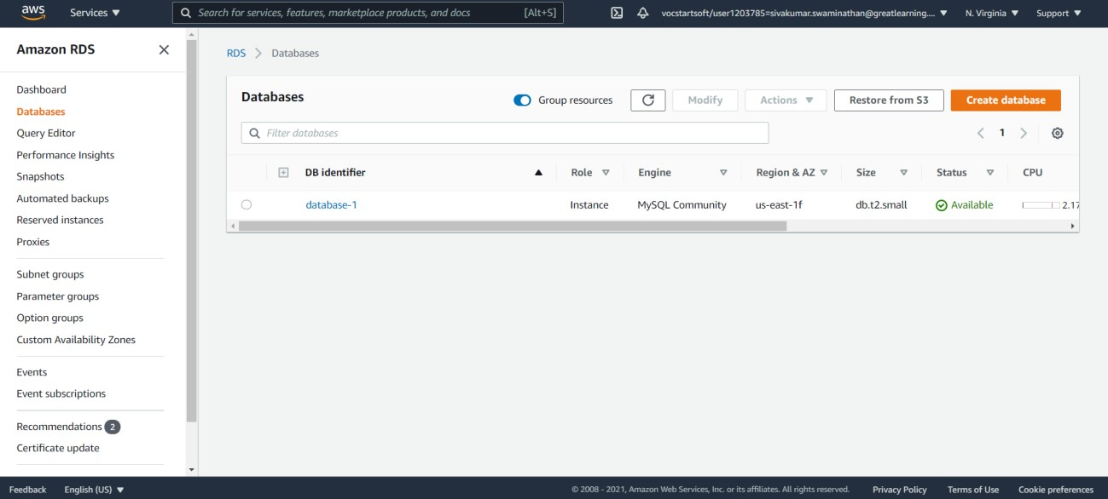

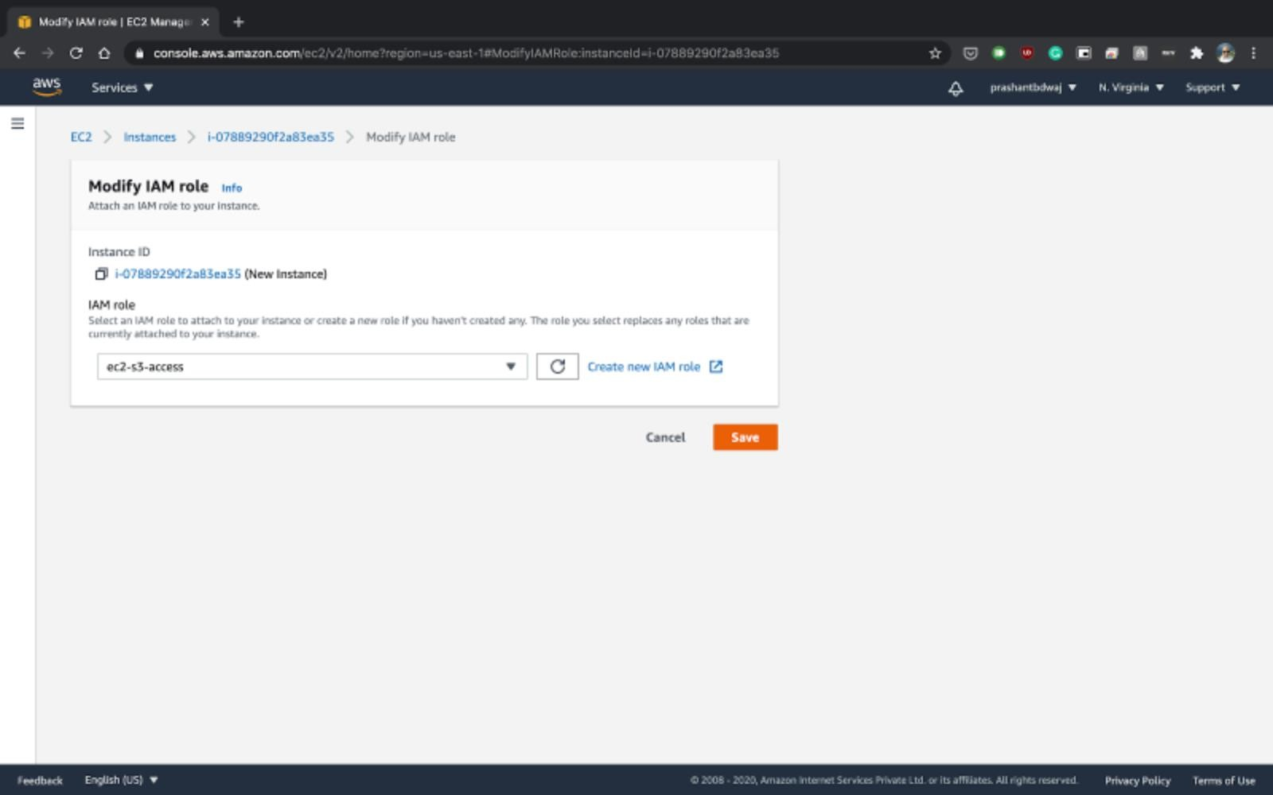

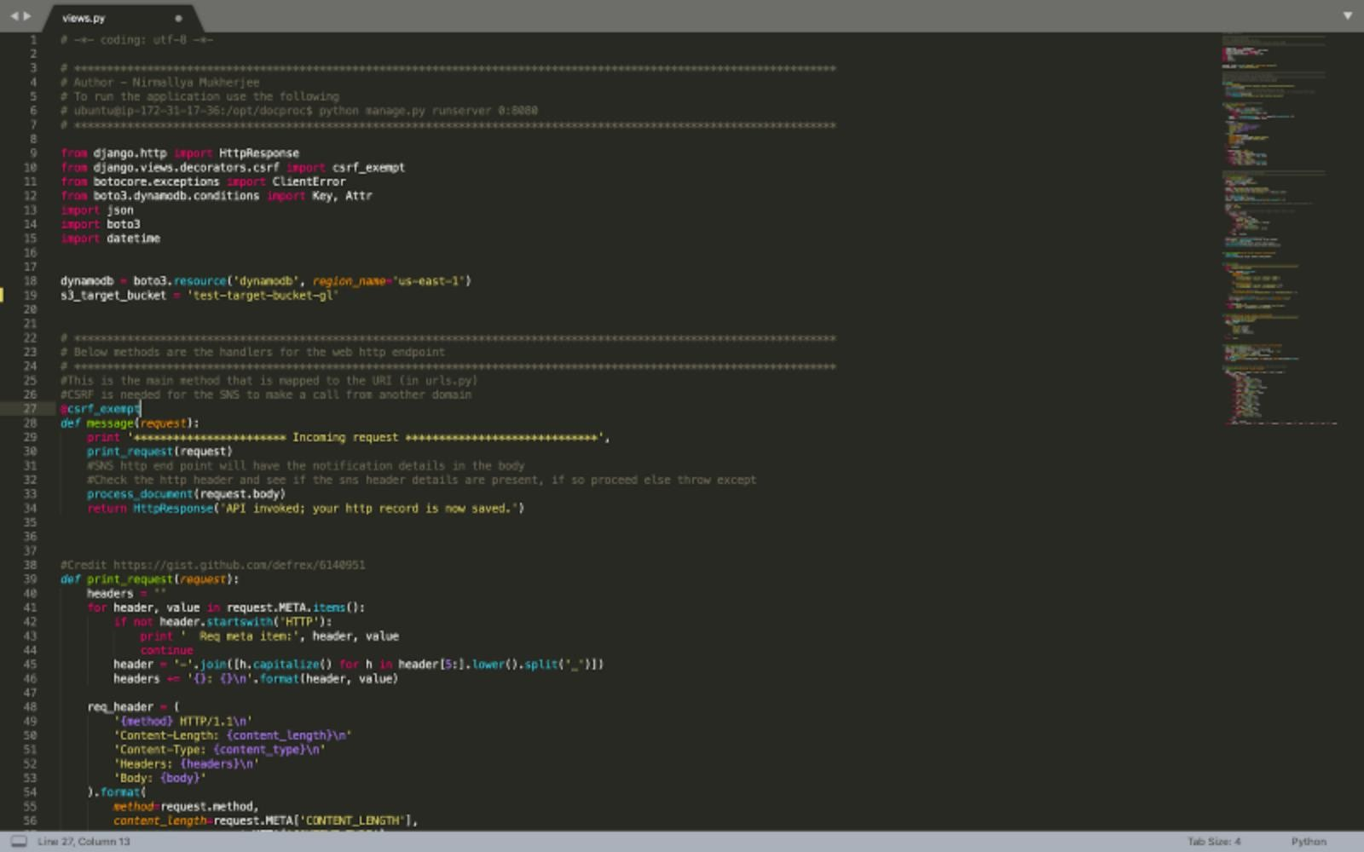

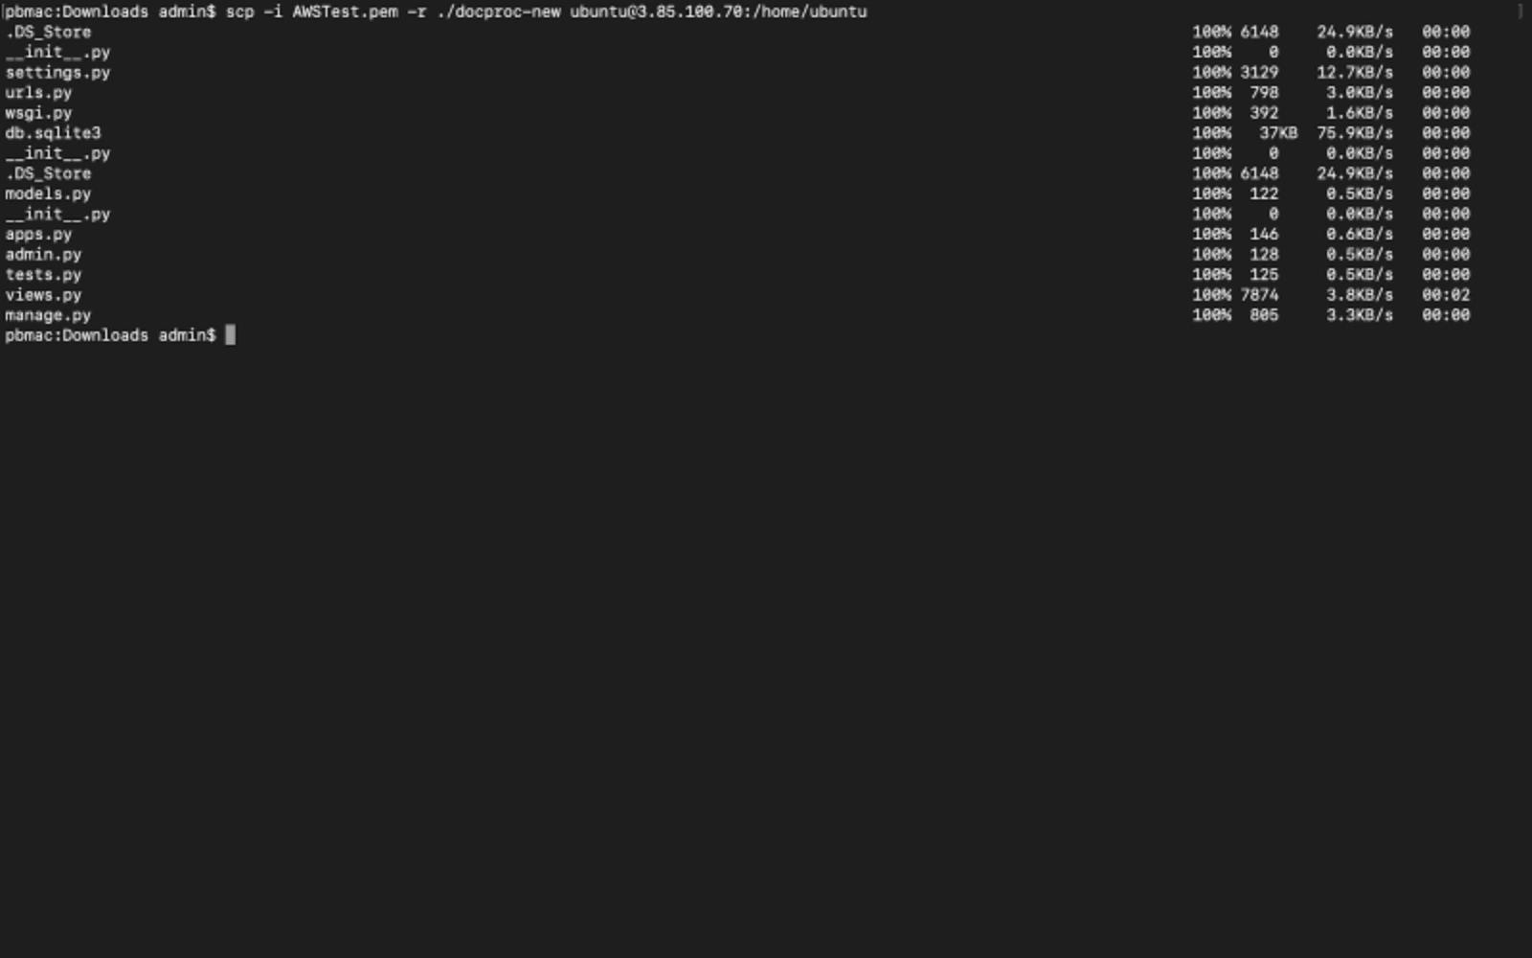

# Step 3

